**Securing App engine using IAP (Identity – Aware Proxy):**

1. Select a project on which you are working
2. Go to -> Security -> Identity-Aware Proxy
3. Under Https-Resources, select the app engine and turn the IAP ton on state.
4. To add the users on a particular service , select the particular service for which you want to give users access to,
5. Then click on Add member
6. Inside new members add a domain name (like teksystems.com)
7. Select a role -> Cloud IAP -> IAP-secured Web App User and click save.
8. Note: Now you will not be able to access the app-engine directly from the browser.

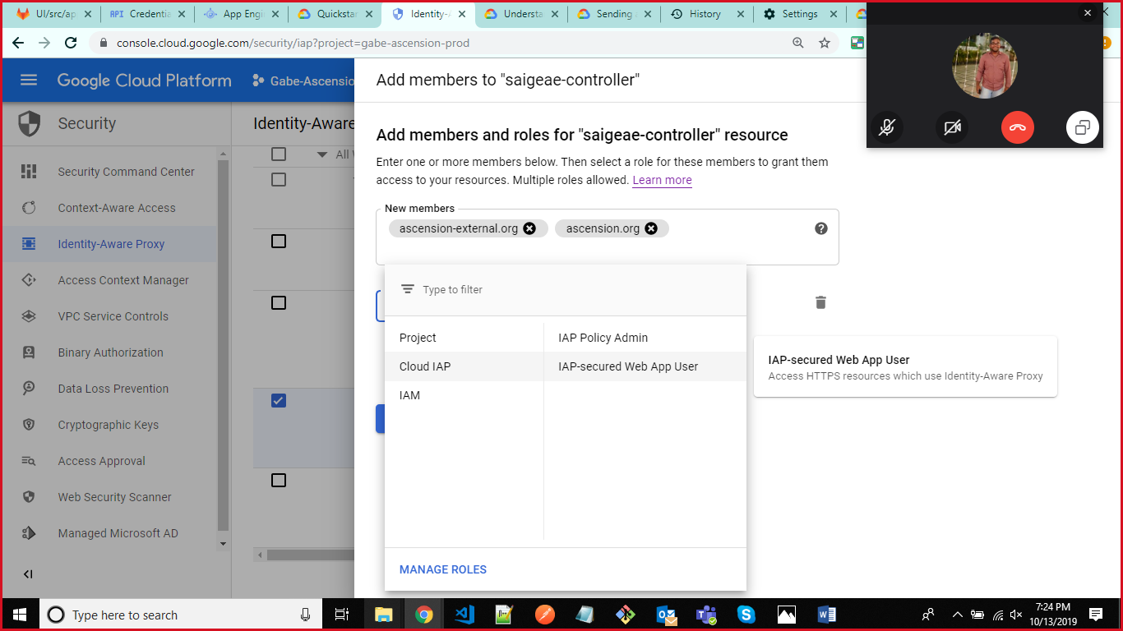

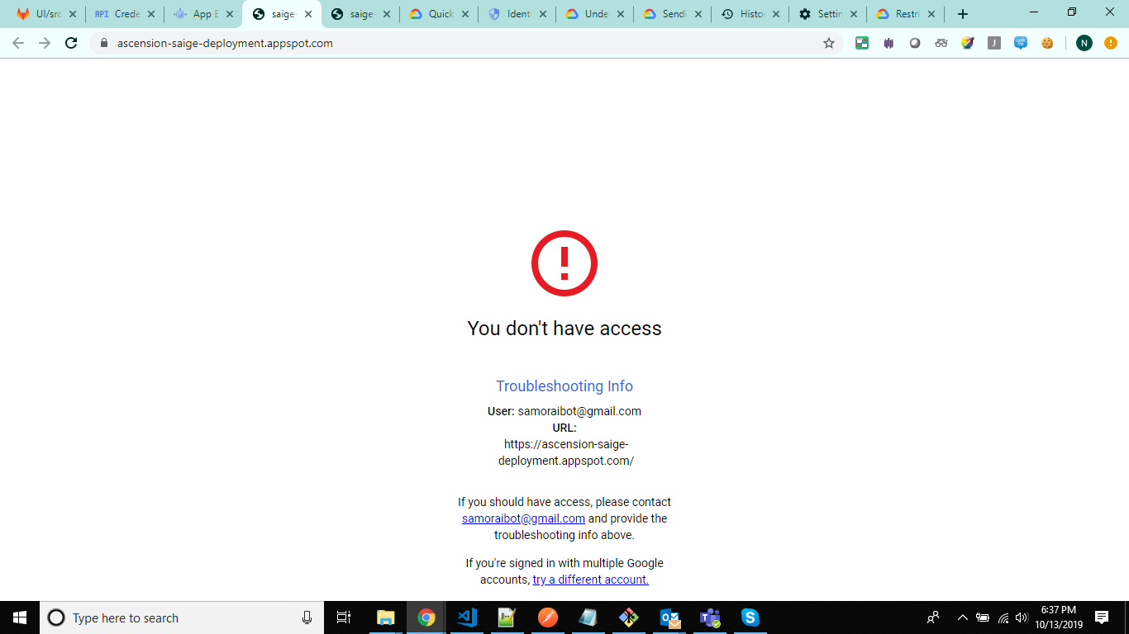

1. Now to access the app engine using the token provided after logging by the user, proceed the following steps:
2. Go to APIs and Services -> Credentials
3. Then click Create credentials -> OAuth client Id -> Select Application type as Web Application
4. Give name and also add the Authorized JavaScript Origins from where your application will be running (ex. <http://localhost:4200> if you are testing on local)

Then click create , once it gets created , copy the client id and use it in the frontend code to fetch the details of the user such as first name , image, token etc.

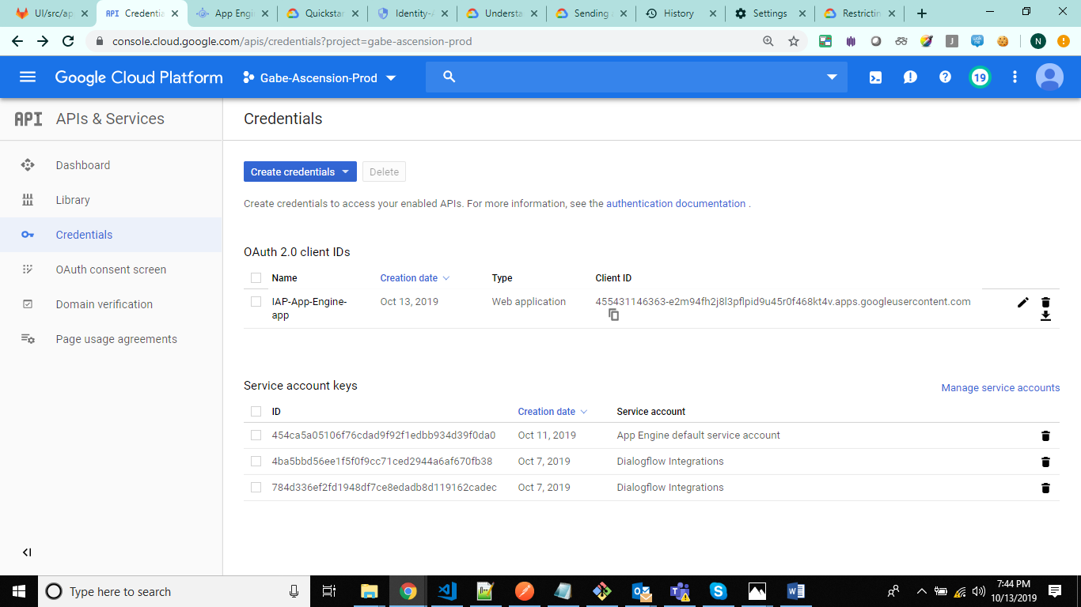

Links:

<https://dzone.com/articles/api-authentication-with-gcp-identity-aware-proxy>

<https://cloud.google.com/iap/docs/app-engine-quickstart>

<https://cloud.google.com/endpoints/docs/frameworks/java/creating-client-ids>

<https://cloud.google.com/endpoints/docs/frameworks/java/javascript-client>

<https://developers.google.com/identity/sign-in/web>